**Create authentication service that returns JWT**

**Step 1:**

Create a Maven project using <https://start.spring.io/> along with the dependency spring web tools.

**Step 2:**

Create Security folder in src \ main \ java \ com \ cognizant \ spring-learn1 and create the SecurityConfig.java code as follows

package com.cognizant.spring_learn1.security;

import org.springframework.context.annotation.Bean;

import org.springframework.context.annotation.Configuration;

import org.springframework.security.config.annotation.web.builders.HttpSecurity;

import org.springframework.security.web.SecurityFilterChain;

@Configuration

public class SecurityConfig {

@Bean

public SecurityFilterChain filterChain(HttpSecurity http) throws Exception {

http

.csrf(csrf -> csrf.disable())

.authorizeHttpRequests(auth -> auth

.requestMatchers("/authenticate").authenticated()

.anyRequest().permitAll()

)

.httpBasic(httpBasic -> {});

return http.build();

}

}

**Step 3:**

Create controller class in src \ main \ java \ com \ cognizant \ spring –learn1 as AuthenticationController.java

package com.cognizant.spring_learn1.controller;

import io.jsonwebtoken.Jwts;

import io.jsonwebtoken.SignatureAlgorithm;

import org.springframework.http.ResponseEntity;

import org.springframework.web.bind.annotation.*;

import java.util.Base64;

import java.util.Date;

import java.util.HashMap;

import java.util.Map;

@RestController

public class AuthenticationController {

private static final String SECRET_KEY = "secret123";

@GetMapping("/authenticate")

public ResponseEntity<Map<String, String>> authenticate(

@RequestHeader("Authorization") String authHeader) {

if (authHeader != null && authHeader.startsWith("Basic")) {

String base64Credentials = authHeader.substring("Basic".length()).trim();

byte[] credDecoded = Base64.getDecoder().decode(base64Credentials);

String credentials = new String(credDecoded);

String[] values = credentials.split(":", 2);

String username = values[0];

String password = values[1];

if ("user".equals(username) && "pwd".equals(password)) {

String token = Jwts.builder()

.setSubject(username)

.setIssuedAt(new Date())

.setExpiration(new Date(System.currentTimeMillis() + 600000)) // 10 min

.signWith(SignatureAlgorithm.HS256, SECRET_KEY)

.compact();

Map<String, String> tokenMap = new HashMap<>();

tokenMap.put("token", token);

return ResponseEntity.ok(tokenMap);

}

}

return ResponseEntity.status(401).build();

}

}

**Step 4:**

Create the pom.xml with the following dependencies

<?xml version="1.0" encoding="UTF-8"?>

<project xmlns="http://maven.apache.org/POM/4.0.0" xmlns:xsi="http://www.w3.org/2001/XMLSchema-instance"

xsi:schemaLocation="http://maven.apache.org/POM/4.0.0 https://maven.apache.org/xsd/maven-4.0.0.xsd">

<modelVersion>4.0.0</modelVersion>

<parent>

<groupId>org.springframework.boot</groupId>

<artifactId>spring-boot-starter-parent</artifactId>

<version>3.5.3</version>

<relativePath/> <!-- lookup parent from repository -->

</parent>

<groupId>com.cognizant</groupId>

<artifactId>spring-learn1</artifactId>

<version>0.0.1-SNAPSHOT</version>

<name>spring-learn1</name>

<description>Demo project for Spring Boot</description>

<url/>

<licenses>

<license/>

</licenses>

<developers>

<developer/>

</developers>

<scm>

<connection/>

<developerConnection/>

<tag/>

<url/>

</scm>

<properties>

<java.version>17</java.version>

</properties>

<dependencies>

<dependency>

<groupId>org.springframework.boot</groupId>

<artifactId>spring-boot-starter-web</artifactId>

</dependency>

<dependency>

<groupId>org.springframework.boot</groupId>

<artifactId>spring-boot-devtools</artifactId>

<scope>runtime</scope>

<optional>true</optional>

</dependency>

<dependency>

<groupId>org.springframework.boot</groupId>

<artifactId>spring-boot-starter-test</artifactId>

<scope>test</scope>

</dependency>

<dependency>

<groupId>org.springframework.boot</groupId>

<artifactId>spring-boot-starter-security</artifactId>

</dependency>

<dependency>

<groupId>io.jsonwebtoken</groupId>

<artifactId>jjwt</artifactId>

<version>0.9.1</version>

</dependency>

<dependency>

<groupId>javax.servlet</groupId>

<artifactId>javax.servlet-api</artifactId>

<version>4.0.1</version>

<scope>provided</scope>

</dependency>

<dependency>

<groupId>javax.xml.bind</groupId>

<artifactId>jaxb-api</artifactId>

<version>2.3.1</version>

</dependency>

</dependencies

<build>

<plugins>

<plugin>

<groupId>org.springframework.boot</groupId>

<artifactId>spring-boot-maven-plugin</artifactId>

</plugin>

</plugins>

</build>

</project>

**Ouput:**

Run the java application

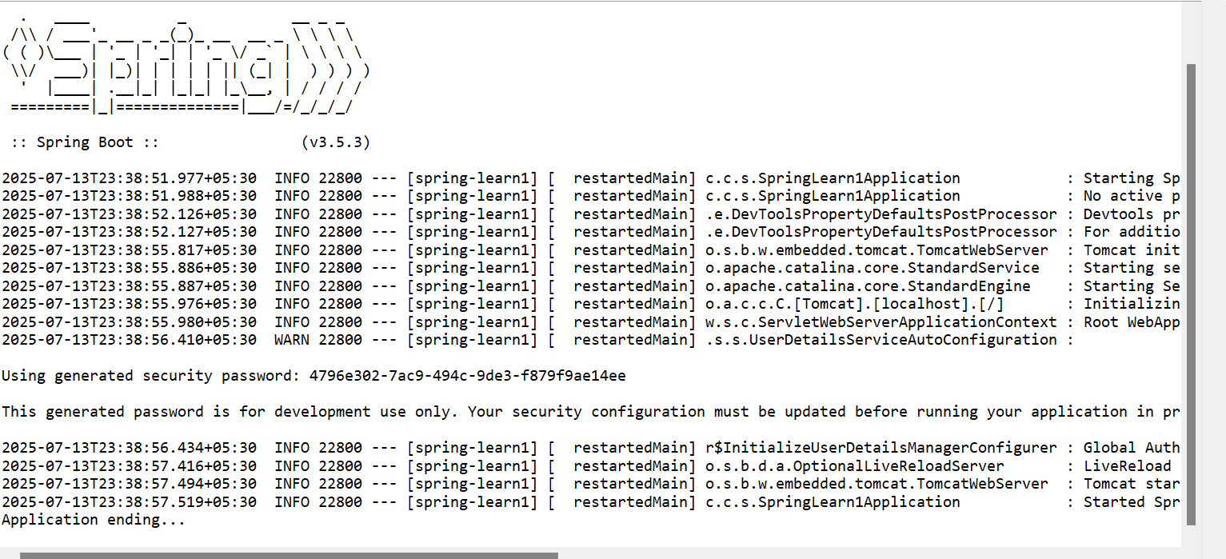

Open the command promp using the command cmd and type in

curl -s -u user:pwd <http://localhost:8083/authenticate>

When authenticated properly it will generate the token



When not authenticated properly

